**Explain git ignore**

**.gitignore** is a special text file you create in your repository's root directory to tell Git to ignore specific files or directories. This is crucial for keeping your repository clean and focused on essential project files.

**Explain how to ignore unwanted files using git ignore**

1. **Create the file**: In your project's root folder, create a new file and name it exactly .gitignore.
2. **Add patterns**: Open the file and add a new line for each file or pattern you want to ignore

**Create a “.log” file and a log folder in the working directory of Git. Update the .gitignore file in such a way that on committing, these files (.log extensions and log folders) are ignored.**

**Verify if the git status reflects the same about working directory, local repository and git repositor**

Before adding the file name to be igorned in a .gitignore

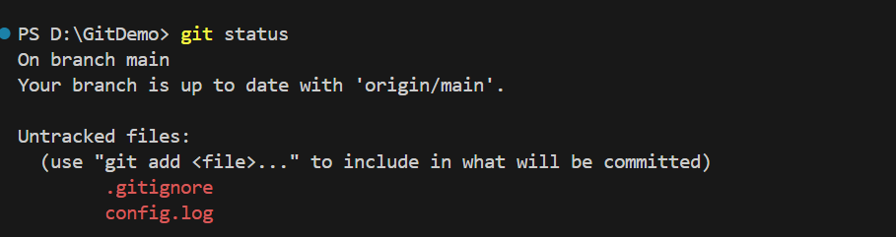

After the adding the file name in .gitignore file

